2/19/15
Dear NVA Parents and Guardians,

News:
Class Dojo “50” Party: As you may recall, one of my classroom incentives to encourage students to make above-and-beyond good choices as a whole community is when every student reaches the 50-point milestone on Class Dojo, they get to celebrate with a party of their own choice! Well, we are only a few points away from meeting that goal! Look for news in the upcoming weeks of what they have chosen.

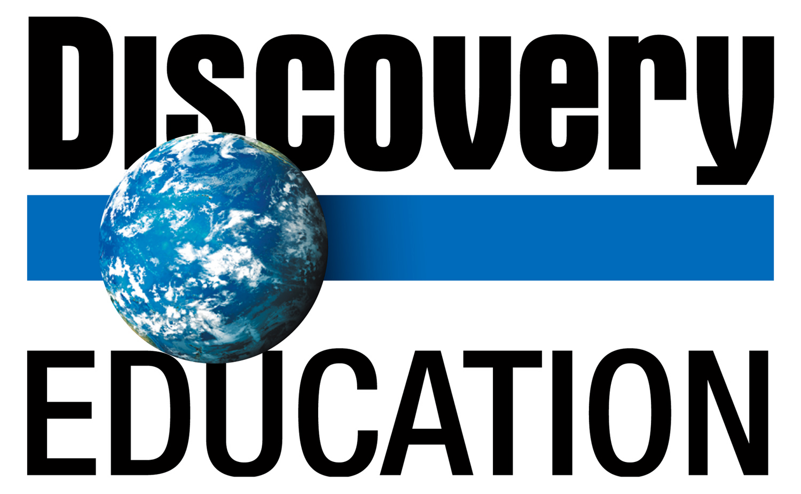
Discovery Education Testing: My students are in the midst of taking their 3rd state test. The testing window closes next Friday. Results will be sent home shortly thereafter.

Upcoming Events:

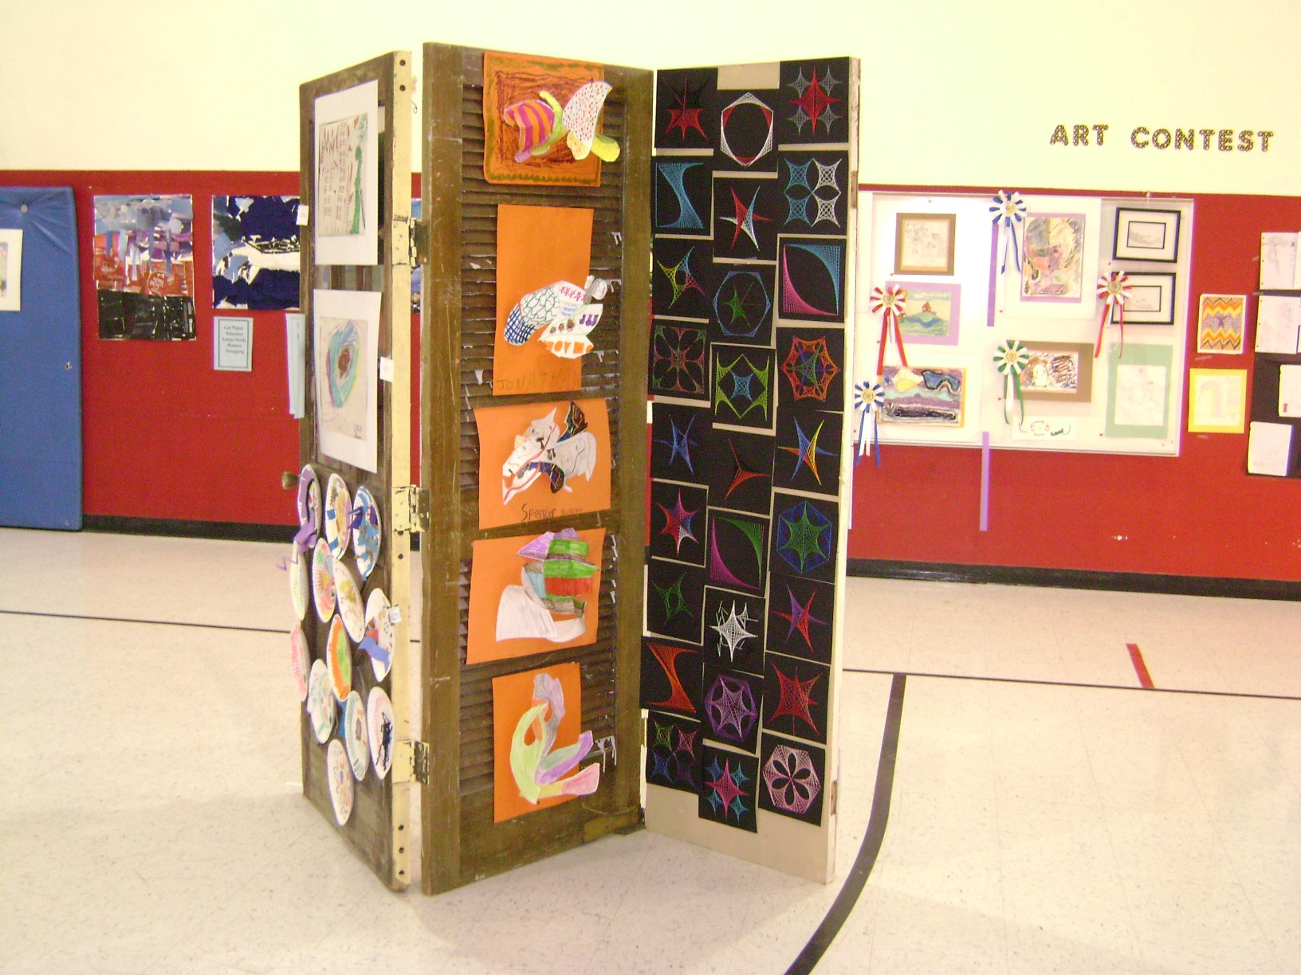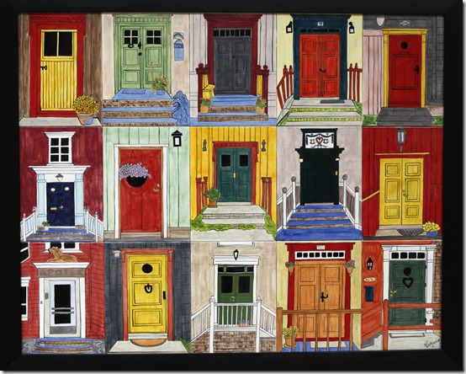
Doorway to the Arts: Next Friday, February 27, 2015 from 6 pm-8 pm is our annual artistic school fundraiser. My class will be displaying an art project on a set of hinged doors, which you will be able to purchase with a small donation of your choosing to the school. I am looking for donations of African American-themed children’s books to put into a basket for the silent auction. I’m doing a black history basket, so I’ll also need a basket. Please get them to me by Thursday. If you would like to pair up with another parent and go halfsies, by-all-means!

Continued on back…
Reminders:
Personal Activity Matrix (PAM): We will conducting our bi-monthly track run NEXT Friday, February 27th at noon for a half an hour. It was great to have so many parent volunteers help us out the last time, and I would love to have a few parent volunteers to join us this time in keeping track of our laps! Please make sure you child is wearing appropriate footwear. No boots.

Sincerely,

Bryan Van Norden
2nd Grade Teacher
bvannorden@nvanm.org
505-998-0501 Ext. 115

