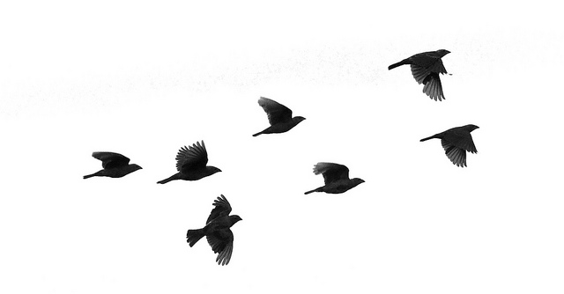
3/25/15
Dear NVA Parents and Guardians,

Wow, just like the birds flying north for the summer months, time is also flying very fast towards summer here at NVA. Here’s some important things to migrate towards:

News:
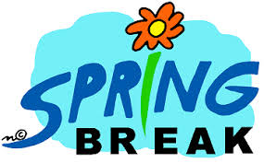
Spring Break Homework: As Spring Break nears, please remember to continue to have your students read over break. I highly recommend using the Raz-Kids website. If, when logging in, it asks you your teacher’s name, just type in: bvannorden. Students should have their passwords memorized. There will not be a homework packet given out over break so the only homework I expect my students to continue to do is read with an adult every day for 20-minutes.

Garden Club: You know it’s officially Spring when Garden Club starts back up. And it does, starting tomorrow right after school and runs until 4:30 pm. I work with the K-2 gardeners, and we’ll be preparing our garden boxes for planting. Ms. Clark has some seedlings started already!

Charlotte’s Web Movie: Both Ms. Sedillo’s class and mine have finished reading the chapter book Charlotte’s Web, and this Friday we will be watching the movie in my classroom together. I would love for a parent or two to donate some healthy snacks for the viewing (I’m thinking fruit of some sort and water).

Continued on back…
Upcoming Events:

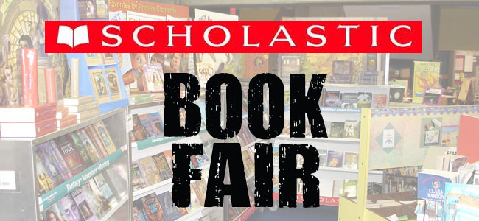
Spring Book Fair: Books will be on sale in the Center for the Arts during the week of April 13th-17th.

Literacy Night: This will be a night full of Literacy activities, guest readers, a storyteller, tips on reading, as well as some prizes (Book Walk!). It takes place on Thursday, April 16th from 5:30 pm-7:30 pm. The second grade team will be playing a game similar to Boggle, where students toss up some big blocks with different letters on each of their six sides, and have to correctly spell as many words as possible with whatever letters they end up rolling. It’s a lot of fun!

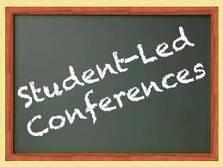
Student-Led Conferences: Yes, I will be preparing students to have them share with you their portfolios, as well as explaining to you their areas of strength and the areas in which they still could improve. Conferences will be Wednesday-Friday, April 15th, 16th, and 17th. These are early release days, so please plan accordingly! I will have a sign-up sheet available after school during pick-up for you to fill in the week after break. However, you can always email me, if that’s easier (I just won’t be able to guarantee you the time you necessarily want).

Continued on next page…

Reminders:
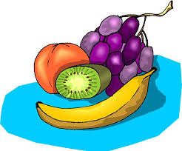
Snack Donations: I would love to receive a few snack donations for those students who forget or whose family cannot afford to bring in a daily snack. Some great healthy snack ideas include raisins, applesauce, fruit cups, etc.
Website Pictures: I just finished updating the pictures on our website. Lots of good times to peruse! Please take a look at your earliest convenience. The address for our class website is:

http://bvannorden.weebly.com/

Sincerely,

Bryan Van Norden
2nd Grade Teacher
bvannorden@nvanm.org
505-998-0501 Ext. 115

