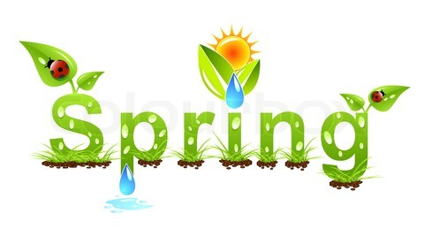
4/8/15
Dear NVA Parents and Guardians,

Voila!:
Upcoming Events:

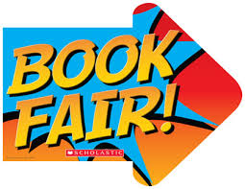Spring Book Fair: Books will be on sale in the Center for the Arts all next week. The book fair will be open for a short period of time after school as well every day next week. Our class will get to preview the selection on Monday, April 13th at 10:30 am. During the preview students are welcome to purchase books. In addition, I will be periodically sending 2 students at a time to purchase books at the fair throughout the week. Also, inside the fair, there is a wall for teachers to request books they would like donated to their classrooms. I will have a list of 5 books of interest to me, and I would appreciate any family’s willingness to purchase any of those books to donate to our classroom library.

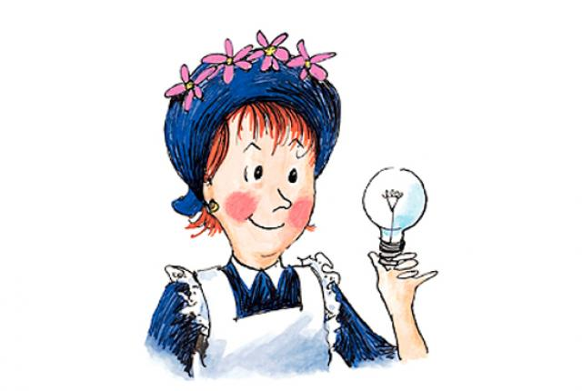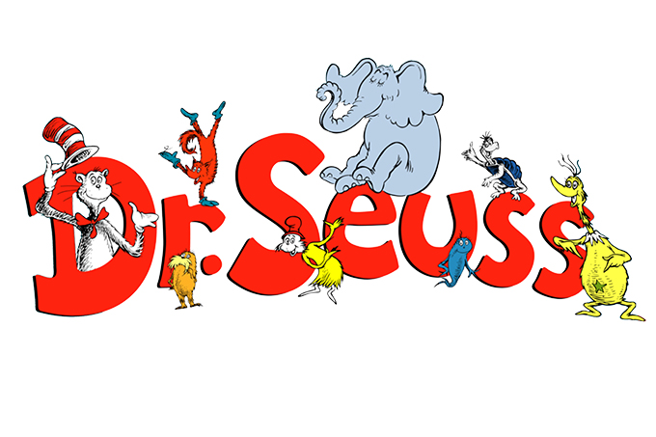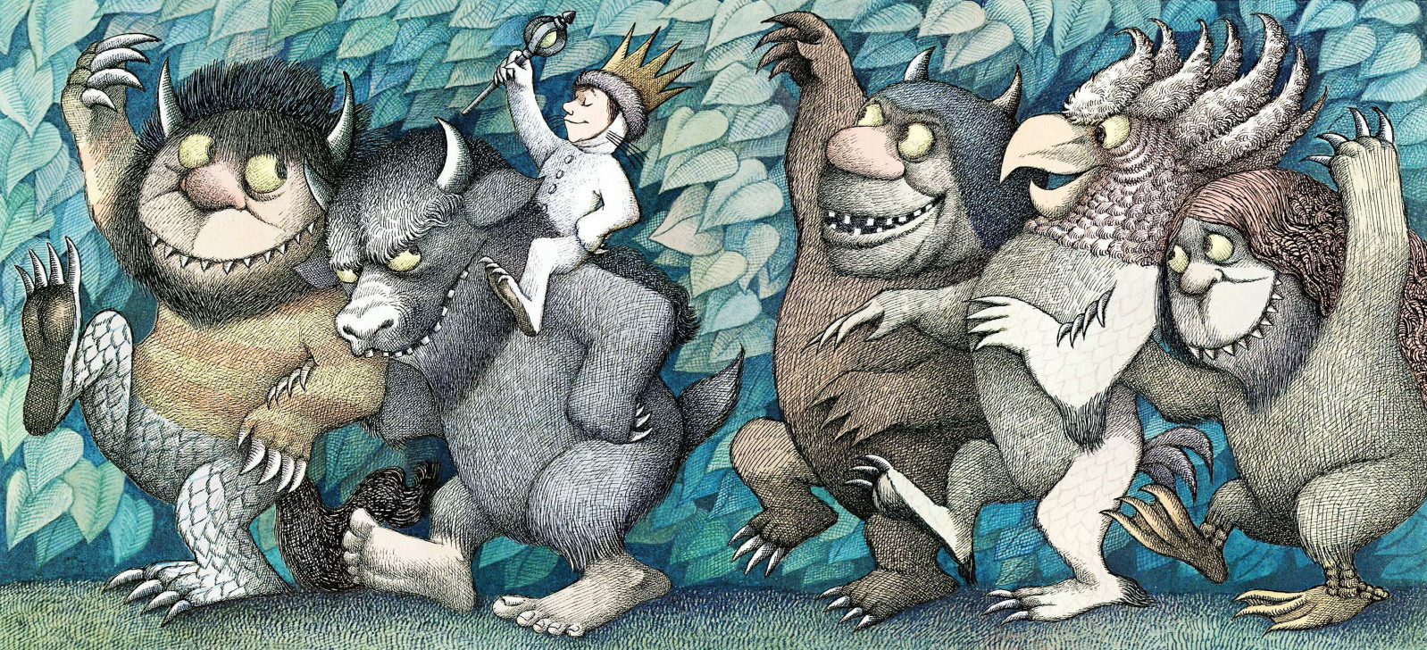
Storybook Parade: Students may dress up as their favorite storybook character on the day of Literacy Night (Thursday, April 16th). The parade begins at 10 am, and you are welcome to come and take pictures.

Continued on back…

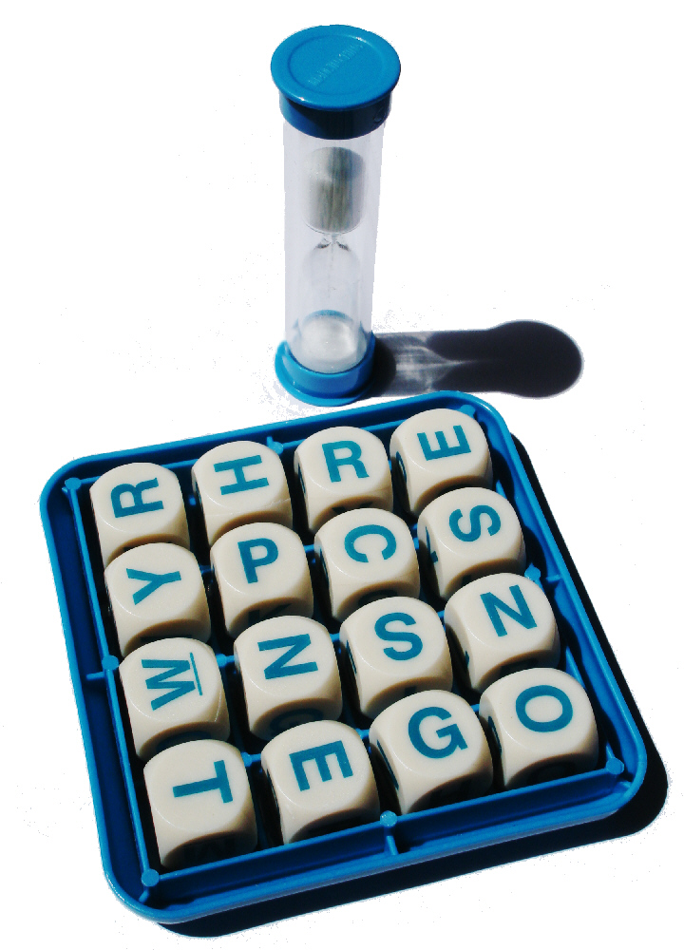
Literacy Night: Next Thursday, April 16th from 6:00 pm-7:30 pm is when Literacy Night occurs. The night will be filled with all sorts of Literacy-themed activities, guest readers, a storyteller, tips on reading, as well as some prizes (Book Walk!). The second grade team will have a Boggle booth, where students get to toss up some big blocks with different letters on each of their six sides and correctly spell as many words as possible with whatever letters they end up rolling. It’s a lot of fun!

Student-Led Conferences: Conferences take place next Wednesday, Thursday, and Friday, April 15th, 16th, and 17th. These are early release days, so please plan accordingly! I am carrying a sign-up sheet with me after school this week so you can pick a time that will work for you. Early next week, I will be sending home a copy of the schedule so you know when to show up for your conference.

Sincerely,

Bryan Van Norden
2nd Grade Teacher
bvannorden@nvanm.org
505-998-0501 Ext. 115

