REVISED VERSION

5/11/15
Dear NVA Parents and Guardians,

With only 12 days left of the school year after today, someone needs to tell the Earth to start orbiting the sun at a much slower pace! In other words, we need more hours in the day! Here’s a look at what we’re cramming in these last 2 and ½ weeks:

News:
Testing, Testing, 1, 2, 3…4: I am currently testing students in DIBELS, Discovery Education, Running Records, and Mathematics. Look for the results before the end of the school year.

Upcoming Events:
Jog-a-thon: Again, we are holding this annual event to Amass-the-Grass on our dirt field. Fundraising sheets were sent home in the Thursday Folder yesterday. Students are given an hour to walk, jog, and/or run the track. When: Wednesday, May 13th from 10:15 am-11:15 am. Parents and guardians-you are more than welcome to join us!

Volunteer Tea: I have had an overwhelming number of parent and guardians volunteer in some

Continued on back…
fashion this year, and I am absolutely being earnest when I say, your help has been nothing short
of extraordinary. From those of you who have donate books and gifts, snacks, and most
importantly your time, I am indebted to your kindness. As a meager “thank you”, anyone who has come to this school and volunteered their time this year are encouraged to come and enjoy the desserts, flowers, and drinks. It takes place on Friday, May 15th from 1:30 pm-2:30. Just know you are appreciated!
Last-of-the-Year Field Trip: We will be joining Mrs. Reid and Mrs. Pattison (along with the other two second grade classrooms) for a field trip to the North Valley Library. See the attached letter describing the trip. Attached to that is the permission slip form. Please return those by Friday, May 15th at the latest. We will be leaving at 9:30 am and returning by 11:30 am on Tuesday, May 19th. No sack lunch needs to be sent, as we will be back for lunch.

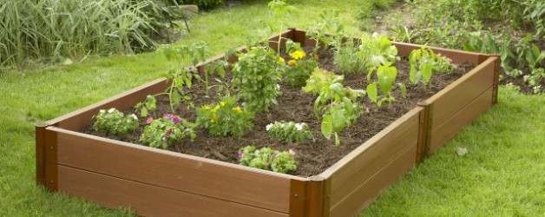
Garden Club: Now that we have new soil for our garden boxes, my garden club members will begin planting seeds in our class’s garden box. I’m going for a green theme as we’ll be planting green chard and kale. These are gifts that truly keep giving all summer long! When: Next Thursday, May 21th right after school until 4 pm.

Summer Birthday Celebration: Because a lot of my students celebrate their Birthday during the Summer months when we are not in school, I am setting aside some time so as to formally recognize them on Friday, May 22nd. I am simply asking that not every student bring in food for their occasion, as there would be an overabundance of it. Later this week, I will be coordinating with students to see who would like to bring in the treat, a drink, a hand-made gift, etc.

Continued on next page…
Field Day: A whole lot of planned outdoor activities for students to participate in will be
happening. Parents and guardians, you are welcome to come and watch (and even volunteer one last time, if you would like). This takes places on Wednesday, May 27th.

End-of-the-Year Awards: Every student will be getting an award. I plan to hand these out formally on the last day of school (Thursday, May 28th at noon). Parents and guardians are
welcome to come and watch. I will be offering up a few positive words about each of my students, as they very much deserve the kudos. They have each worked extremely hard this year!

Reminders:

Thursday Folder: Make sure you are checking the Thursday Folder each week, as there is often a lot of information provided, and I do not always repeat it here.

Track Laps: We have just two more times where I will be recording our track laps for the state. They are to be held on Friday, May 15th and Friday, May 22nd, weather provided. On both Fridays, we will start at 10:30 am, and students will walk, jog, and/or run for a half-an-hour.

Memorial Day: There is no school on Monday, May 25th. Please plan accordingly.

Last Day of School: The last day of school for students is on Thursday, May 28, and it is a 1 pm release. Please plan accordingly!

Sincerely,

Bryan Van Norden
2nd Grade Teacher
bvannorden@nvanm.org
505-998-0501 Ext. 115

