10/23/14
Dear NVA Parents and Guardians,

It’s nearly Halloween so I thought I should unearth some upcoming ghoulish fun!
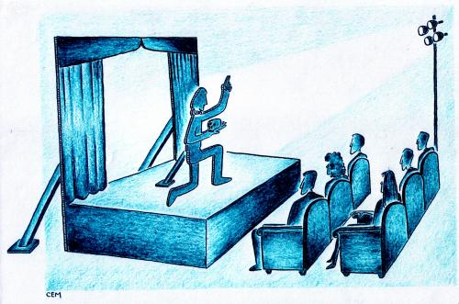
Play Writing & Performance: Because we have been reading the drama entitled “The Strongest One” in class, your child has also been working with a buddy to write their own drama. These will be relatively short plays, which will be acted out next Thursday, October 30, 2014 beginning at noon. Students will be making masks to wear, and you are welcome to attend.

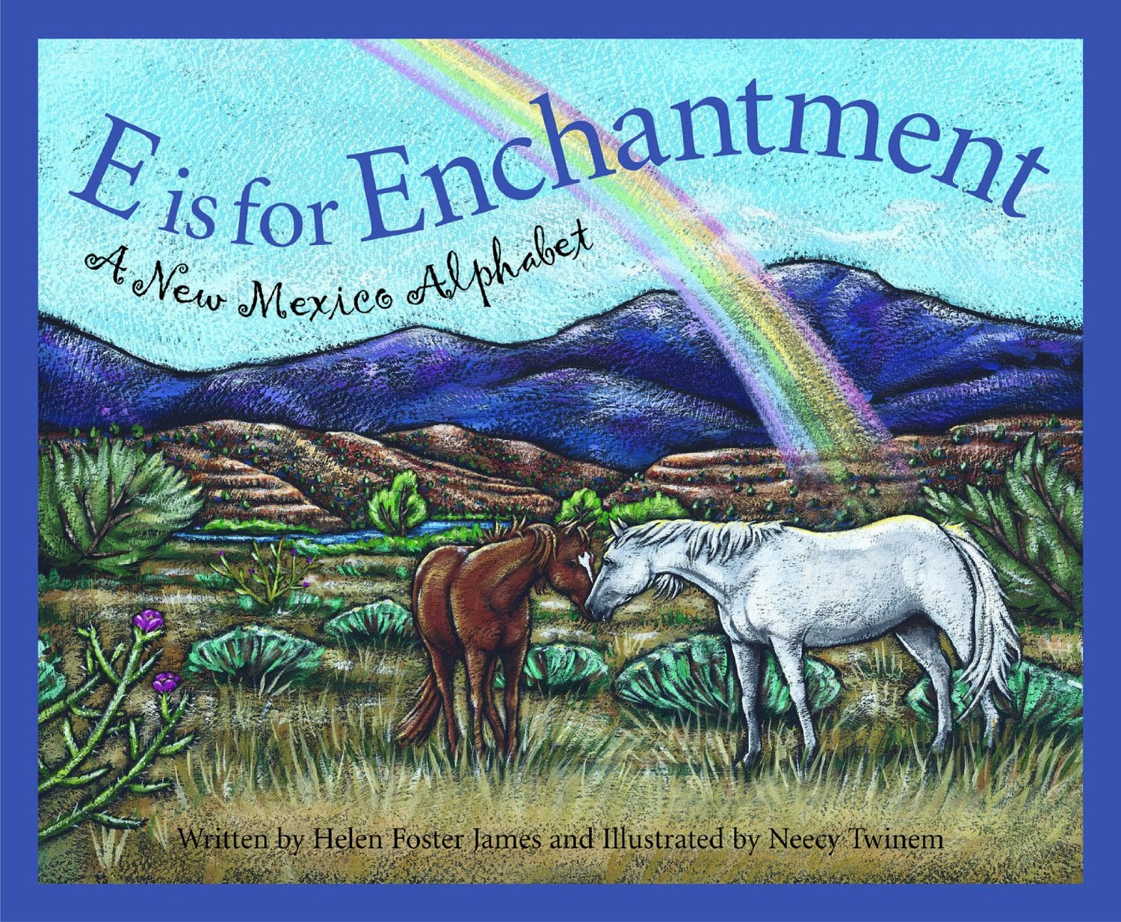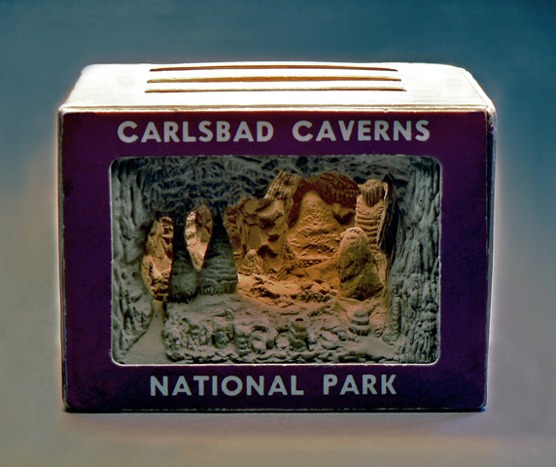
New Mexico Culture Project: Miss Sedillo and I have decided to have our students individually work on a cultural project about our state in association with our school’s monthly themes for October and November, which are “New Mexico” and “American History; Cultures and Tradtions” respectively. We each began by reading the book “E Is For Enchanted” about New Mexico’s culture and traditions to our classes. Then, we drew names to see which student was assigned to which topic. Most of the project will be done in class, but students are expected to do some research at home on their topic (for example: they are to pick up a book on their topic at the library, and/or do a web search on said topic with your guidance), as well as put together a diorama (a miniature model) about their topic. A full rubric and list of the writing standards we will be covering will be sent home next week.

continued on the back…
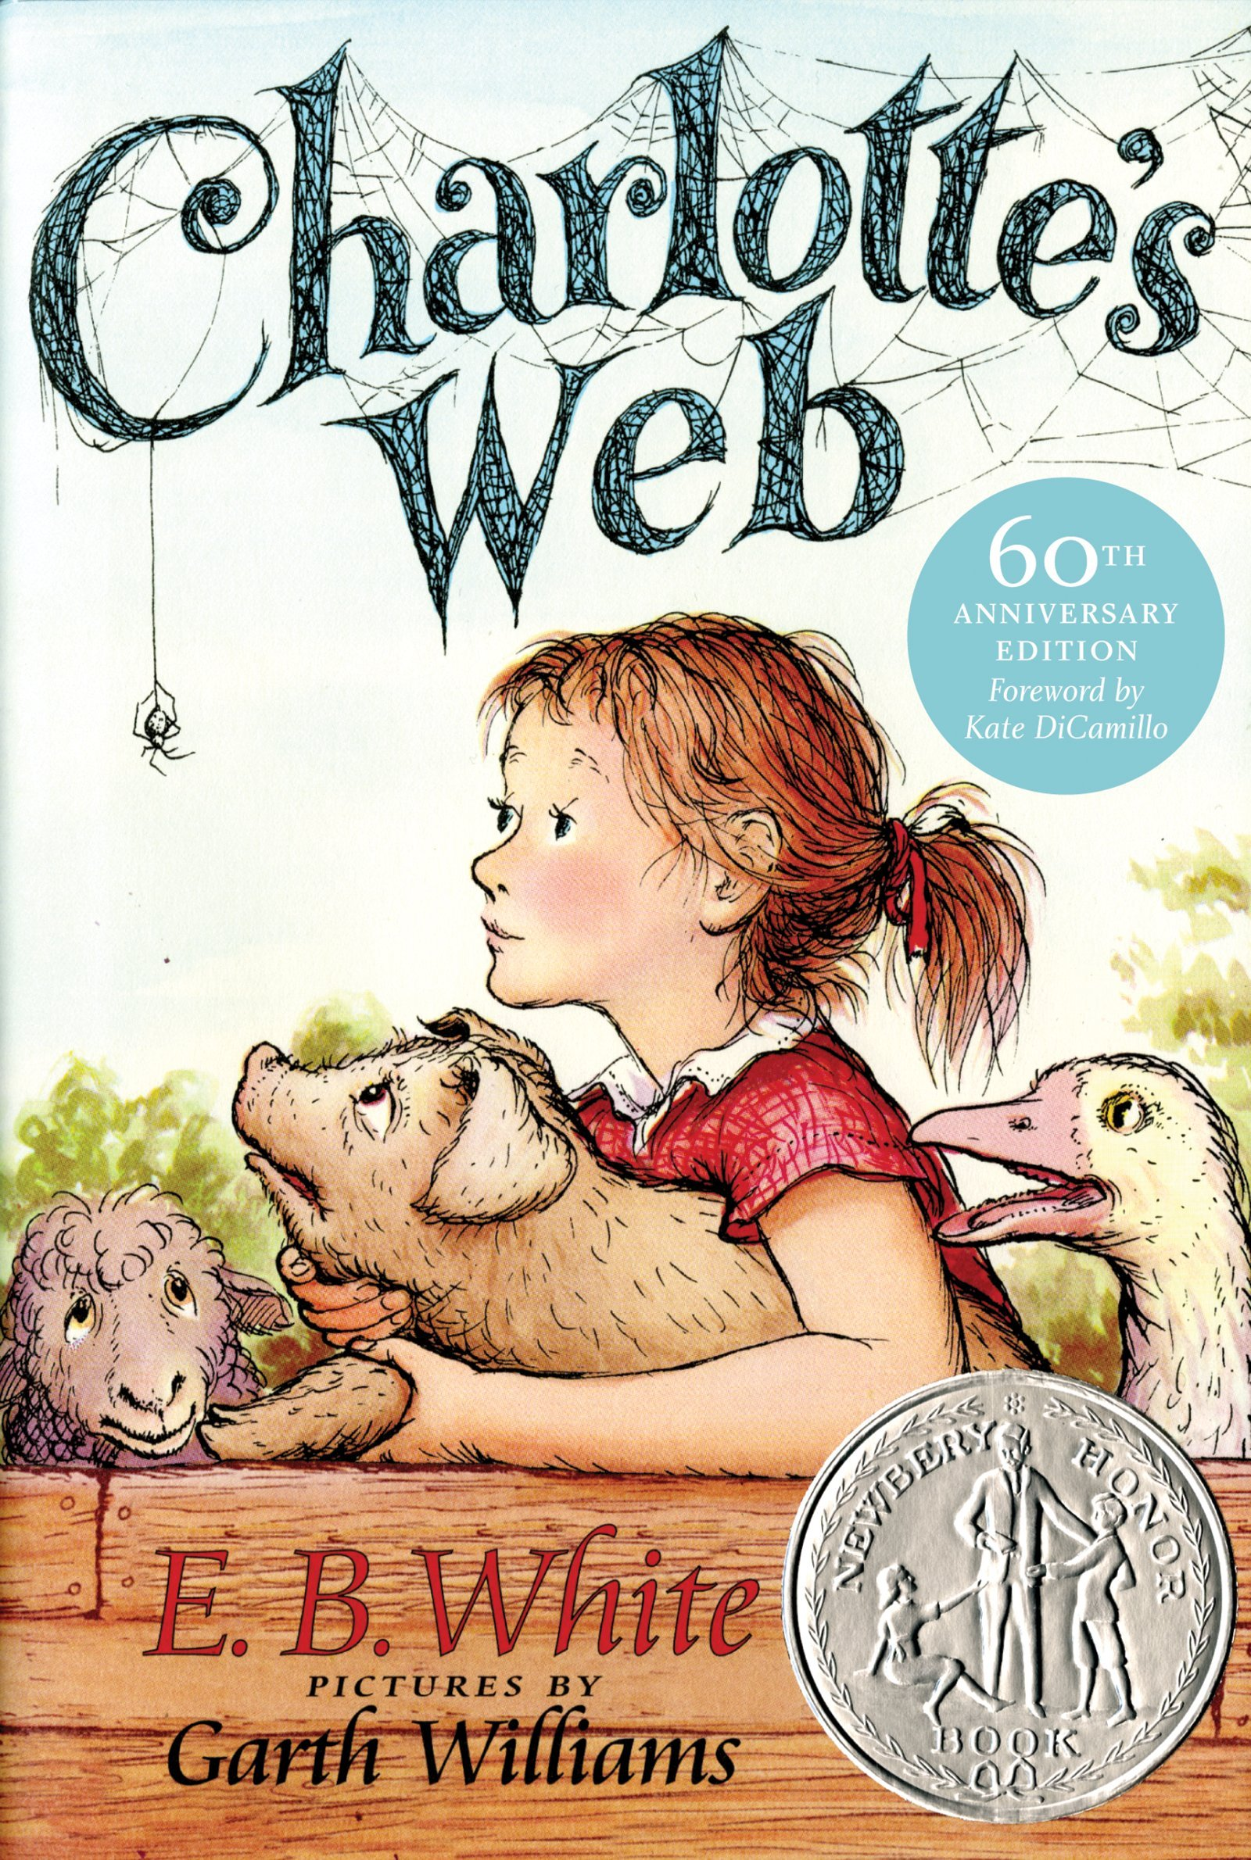
“Charlotte’s Web” Reading and Movie: Miss Sedillo’s second grade class and mine have also joined forces to read the chapter book “Charlotte’s Web” to our classes. When we finish, we plan to have our students watch the movie. The goals are to have them get used to having chapter books read aloud to them, as well as having them compare and contrast the film to the book.

Reminders:

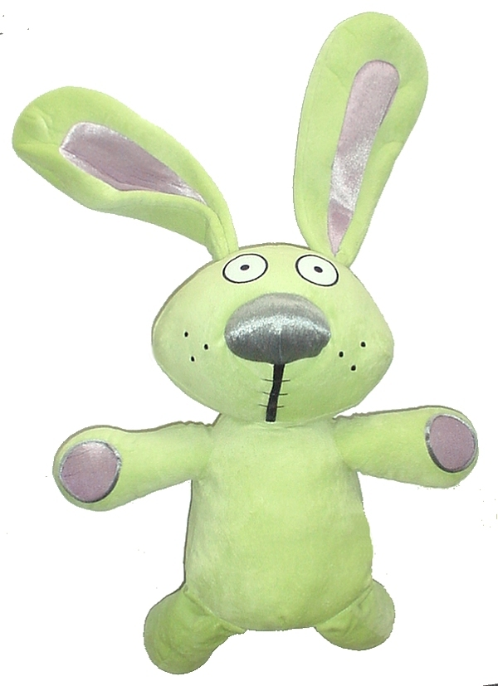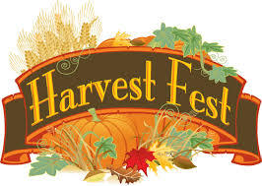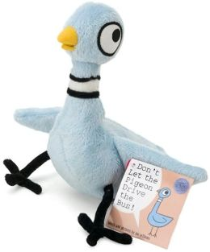
Harvest Fest: Harvest Fest takes place on Thursday, October 30th from 5:30-7:30, and I’m still looking for books and/or accessories for our Mo Willems basket, which will be auctioned off during the silent auction. He is the author of many great books such as the Knuffle Bunny Series, the Pigeon series, and the Elephant and Pig series. Thus far, I have only received two books by him! Please get them into me by next Wednesday at the very latest. Remember all the money raised during the silent auction goes to our classroom’s fund!
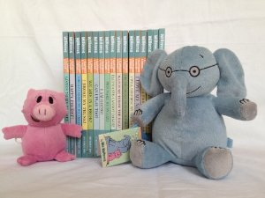

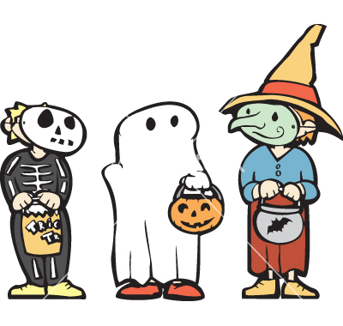
Costume Parade: At “10 am” on Halloween day, our school will be hosting a Costume Parade. All students are welcome to dress up for that day.

