10/27/14
Dear NVA Parents and Guardians,

Hold on to your Halloween masks, it’s going to be an eerily busy week. As such, I thought I would send home a few updates and reminders:

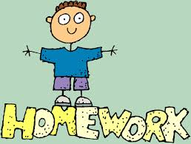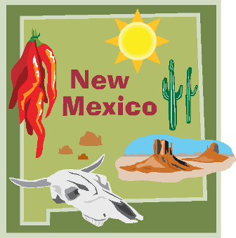
This Week’s Homework Packet & The New Mexico Cultural Project: Because Ms. Sedillo and I are having our students begin a project on New Mexico culture, I am only sending home Math this week, and a creepily-themed poem for their Backpack Reader. Remember, for their Backpack reader they must read for 20-minutes each weeknight (and I highly encourage you to read with them about their topic), as well as time themselves on their Time-To-Read poems. The rest of the Literature portion to this week’s homework is to have your child find a book on their topic and/or research their topic online. They will need to bring their book and/or a print out of their web pages in on Monday, November 3rd, as we will begin the writing portion of the project that week in class. They also should start planning and designing their dioramas or posters on their topic. These will be due the following week on Monday, November 10th. The project rubric and checklist is attached to this letter.
Play Writing & Performance: Your child has been hard at work with a buddy putting the finishing touches on the final draft of their play. This week they will be completing their play, making character masks, and practicing them in front of their classmates. Their acting skills are formally set to be on display this Thursday, October 30, 2014 beginning at noon. You are most welcome to attend!

Continued on back…

Reminders:

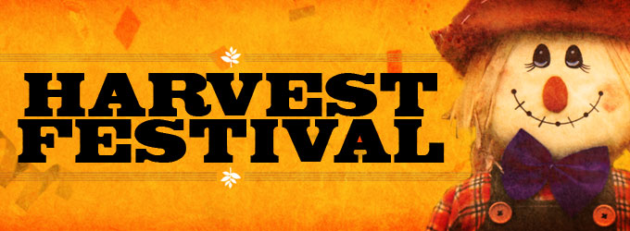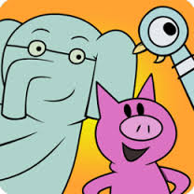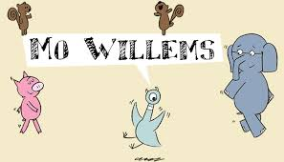
Harvest Fest: ***Correction***Harvest Fest takes place this Thursday, October 30th from 5 pm-7 pm, not 5:30 pm-7:30 pm as I originally stated. Sorry for any confusion. Get those Mo Willems items in for the silent auction. I will be accepting them until Wednesday at the very latest. Mrs. Everist (3rd grade teacher), and I will be hosting a “Ghost Toss” game that evening, and we would love to have some parents/guardians volunteer to help us out at our booth. We’re also looking for donations of prizes and/or a cake for the Cake Walk. Wristbands are on sale now for $9 ($10 at the door). Students are welcome to come dressed in their costumes too!

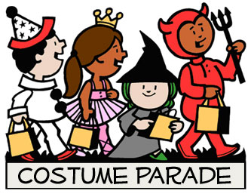
Costume Parade: At 10 am on Halloween day (Friday, October 31st), our school will be hosting a Costume Parade. All students are welcome to dress up for that day, and parents/guardians are welcome to attend. Because students will be receiving goodies during the parade, we will not be having a separate Halloween party in my classroom. I feel that would be sugar-laden overkill. However, my students will be doing some Halloween-themed activities in class. Plus, we have Birthdays to celebrate on both Thursday, October 30th, and Friday, October 31st.

Sincerely,

Bryan Van Norden
2nd Grade Teacher,
bvannorden@nvanm.org
505-998-0501 Ext. 115

