10/3/14
Dear NVA Parents and Guardians,

There are lots of goings-on. Check ‘em all out:
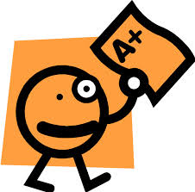
Progress Reports: They were sent home today. Check your child’s backpack. Please remember that it is still early in the semester, and for some subject areas we might have only had one or two graded assignments. The percentages only reflect that.
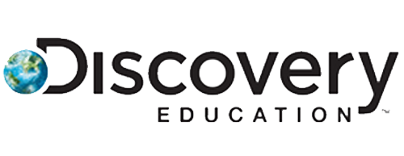
Discovery Education Scores: Your child’s first Discovery Education test scores for both Math and Reading were sent home today, along with their progress reports. I intended to send them home last week, but they were not ready yet. I will be going over these scores during parent/teacher/student conferences, so please take a look at them.

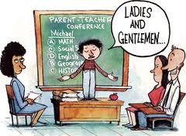
Parent-Teacher-Student Conferences: These are on Monday, Tuesday, and Wednesday of next week. Please contact me for your time. Remember on those three days, students are released at 1 pm, so please plan accordingly.
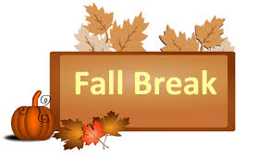
Fall Break: Remember too, that on Thursday, October 9th and Friday, October 10th there is no school. It is Fall Break. I will be sending home a homework packet next week as I would like students to keep the Math and Literacy concepts fresh in their ever evolving minds.

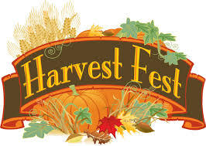
Harvest Fest: Even though Harvest Fest is not until October 30th from 5:30-7:30, I want to get the word out for my class’s gift basket, which will be auctioned off during that evening’s Silent Auction. I would like to put together a basket full of the books by my favorite children’s author Mo Willems. He is the author of many great books such as the Knuffle Bunny Series, the Pigeon series, and the Elephant and Pig series. See some of his popular characters below:
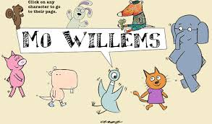
I know my students really enjoy his work, and I think it would sell well. I am looking for donations of his books to include in our basket. You may also donate stuffed Mo Willems-related animals, buttons, etcetera for our basket. Please drop them off in our classroom. Remember all the money raised during the silent auction goes to our classroom funds!

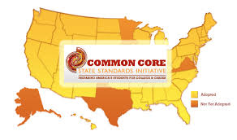
Common Core Informational Night: Do you have questions about the Common Core State Standards that your child is required to learn? Then come to this PTO-sponsored event to have them answered (of course, you can always ask me as well). It takes place on Tuesday, October 21st at 5:30 in the Center for the Arts.

Sincerely,

Bryan Van Norden
2nd Grade Teacher,
bvannorden@nvanm.org
505-998-0501 Ext. 115

