11/19/14
Dear NVA Parents and Guardians,

With the holidays literally right around the corner, leave some extra room for stuffing because there’s plenty of stuff for your eyes to gobble up. Feast your eyes on this:
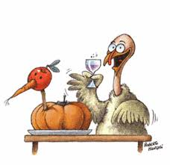
Annual Thanksgiving Luncheon: When: TOMORROW!!! (That is, Thursday, November 20th). Second grade will chow down from 11:30 am-12:20 pm. Give yourself plenty of time, as this day is much like the store’s holiday crowds, insanely busy!

Discovery Education Test #2: We are in the midst of taking Test B for both Mathematics and Language Arts. The testing window closes at the end of the day on Friday, December 12th. Color copies of the results will likely be sent home to you the following week.

Reminders:

Tardies: Remember-students are expected to be in their classrooms at 8 am sharp. I have a number of students who are regularly showing up 15-minutes past the hour. This adds up to roughly 1 hour and 15 minutes of class time that is missed per week. Please ensure your children are showing up on time!

Continued on back…

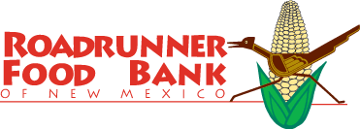
Canned-Food Drive Ending: There are only 2 days left! The drive ends this Friday, November 21st. Please get your non-perishable food items in. I hear there’s quite the competition this year. Most importantly, the food goes towards a very worthy cause!
Pictures & Picture Retakes: Retakes will be taken Tuesday, November 25th. All pictures will be distributed to you as soon as they arrive here.

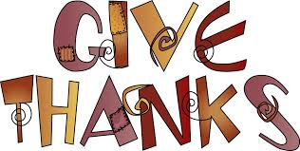
Thanksgiving Break: We only go to school on Monday and Tuesday of next week. Break begins on Wednesday, November 26th, and students come back on Monday, December 1st. Yes, it’ll be December already! NO HOMEWORK PACKET WILL BE GIVEN OUT NEXT WEEK! Your homework is to spend some quality time with your families. Of course, keep reading with your child! Heck, have them go on the Raz-Kids website. It will do wonders to prevent “break regression”.

Sincerely,

Bryan Van Norden
2nd Grade Teacher,
bvannorden@nvanm.org
505-998-0501 Ext. 115

