11/6/14
Dear NVA Parents and Guardians,

There’s good news to share, some really good news, and then just some plain old news. Read all about it:

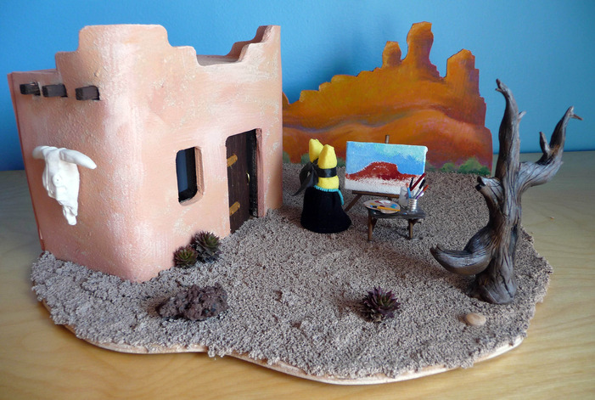
New Mexico Cultural Project Poster/Diorama Deadline Extended: Originally the due date I put forth was Monday, November 10th, but based on the number of students who have yet to start theirs, I have decided to move back the deadline to Monday, November 17th. This will ensure some really good quality, stress-free projects.

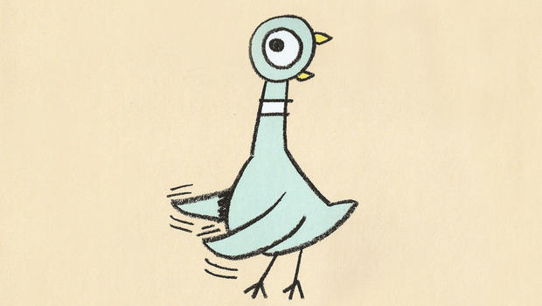
Silent Auction Awesomeness: Thanks in large part to your wonderful last minute Mo Willems additions, we raised a whopping $60 for our class!!! Thank you to all the families that donated books, stuffed animals, and the basket. I know the books went to a very deserving home.

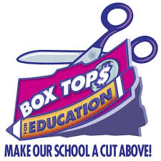
WE WON!: Our class won the Box Tops competition, and I couldn’t be prouder! That’s a tough
fete, but we managed to pull it off. Go you, for cutting all those box tops out for our classroom!

Continued on back…
As a result, my class has earned a Hawaiian Kabob Party. We’re shooting for Friday, November 14th from noon to 12:45 pm. This way, you can pick your kiddo up right after the party.

Reminders:

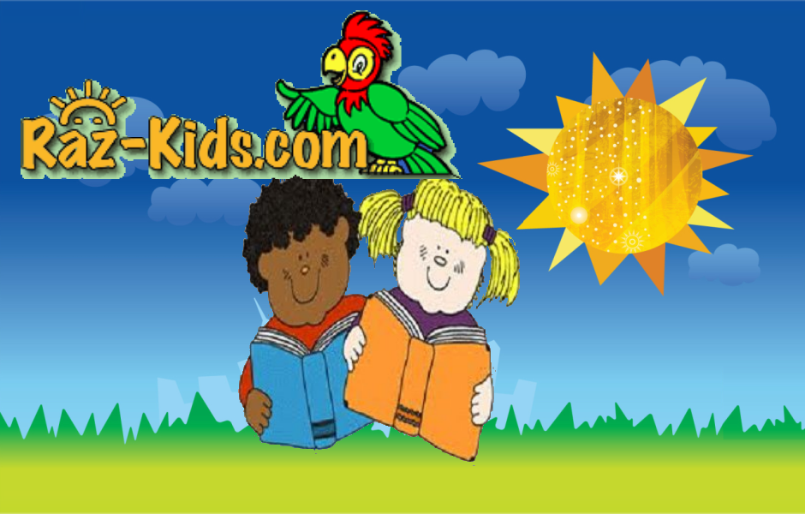
Raz-Kids: I highly encourage your child to use the Raz-Kids website at home for their Backpack Reader’s nightly 20-minutes of reading. Not only have all the books been leveled to fit your child’s backpack reader, but it works on their comprehension as well, by having them take a short quiz after each book is read. This is not to eschew your personal touch of reading with your child (for nothing can replace good quality family time), but it will do wonders for them as readers.

Canned-Food Drive: Get your canned goods in for the food drive and help feed Albuquerque’s hungry! The class that garners the most weight in non-perishable food wins a cookie decorating party. Last year, my class came in second. This year, I’m going for the gold! And believe me, in this case, the heavier the better!

Sincerely,

Bryan Van Norden
2nd Grade Teacher,
bvannorden@nvanm.org
505-998-0501 Ext. 115

