12/9/14
Dear NVA Parents and Guardians,

Like many a holiday meal, there’s usually an overabundance of “goodies” to partake. But like many a sweet tooth craving, remember to ingest the edibles in small doses so as to avoid indigestion. Read through all this indelible eye candy in a similar manner:

Our Daily Schedule:
Monday-Thursday Schedule:

8:00 School Begins
8:05-8:15 Communal Meeting
8:15-8:30 Calendar
8:30-8:53 Math
8:53-9:33 Specials (Art on Tuesdays and Thursdays) / (PE on Wednesdays and Fridays) /
(Computer Lab/Technology on Mondays from 8:55-9:55)
10:00-10:10 Snack
10:10-10:30 Bathroom Break & Recess
10:30-11:25 Math Continued
11:25-11:55 Lunch
11:55-1:15 Literacy (Reading Buddies w/ Mrs. Nye’s 5th Grade on Tuesdays from 1:00-1:15) / (Library on
Wednesdays from 12:30-1:00)
1:15-1:35 Bathroom Break & Recess
1:35-1:45 Teacher Read Aloud
1:45-2:20 Literacy Continued
2:20-2:35 End-of-the-Day Communal Meeting
2:35-2:45 Clean-Up/Jobs
2:45-2:50 Line Up
2:50 Dismissal

Friday Schedule:

8:00 School Begins
8:05-8:15 Communal Meeting
8:15-8:30 Calendar
8:30-8:53 Math
8:53-9:33 PE
9:33-10:00 Math Continued
10:00-10:10 Snack
10:10-10:30 Bathroom Break & Recess
10:30-11:25 Literacy
11:25-11:55 Lunch
11:55-12:20 Literacy Continued
12:20-12:35 End-of-the-Day Communal Meeting
12:35-12:45 Clean-Up/Jobs
12:45-12:50 Line Up
12:50 Dismissal
Letter continued on back…
Daily Parental Volunteers Welcome: I know many of you have filled out the volunteer forms at the beginning of this year expressing your interest about coming in. Since I’ve included our classroom schedule in this letter, the easiest way to make this happen is if you tell me the exact day and timeframe you would like to come in. I have one parent right now who comes in to read aloud to students, and I would love some parents to come in to assist with our morning Math Centers and afternoon Literacy Centers. You’ll get to see your child’s learning in real time, unexpected warts and all.

Winter Pajama Party: Ms. Sedillo and I are getting our 2 classes together next Wednesday to celebrate the end of the first half of the year. Our classes will be watching the original movie of Annie in her room, and all of our students are welcome to come decked out in their most festive holiday pajamas for the last 1/2 day before Winter Break! I am looking for 1 or 2 parent volunteers who would be willing to donate some healthy snacks. Think popcorn, fruit, and water!

Winter Break Reading Incentive Programs: The NVA school library will be sending home a reading log soon to encourage students to read over break. There will also be a grade-level competition for Raz-Kids’ 1st round of comprehension questions, so keep reading those online books, and keep taking those online quizzes over break.

Reminders:
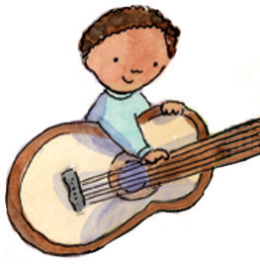
Festival of the Arts Recital: What: A performance of live holiday music via our Eagle Choir and our middle school guitarists. When: This Thursday at 6pm. Where: In the Center for the Arts.
Over the Top Holiday Sweater Contest: Prizes are going to be awarded for the students with the most outlandish knitted wear. Students are encouraged to dress in their silliest garb this Friday.

Report Cards: They go home with students on Wednesday, December 17th. The latest Discovery Education scores will likely be attached. Remember that I do not base my report card findings soley from this state standardized test, but I consider the “whole” student, including what I assess in the classroom.
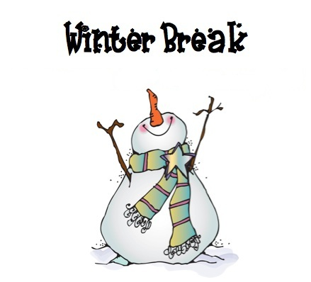
Winter Break: Students are released Wednesday, December 17th at 1 pm and are not expected to return until Wednesday, January 7th. Enjoy your holiday break! No homework packet will be distributed next week. I simply ask that you keep reading with your child at home over break.

Sincerely,

Bryan Van Norden
2nd Grade Teacher,
bvannorden@nvanm.org
505-998-0501 Ext. 115

