9/4/14
Dear NVA Parents and Guardians,

Goodbye August and hello September! You’ve snuck up on us so very quickly. Families, I just wanted to let you know about a few things coming up this late summer horizon:

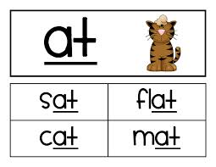
Word Family Tests: By now you’ve probably realized that your child has not been getting Spelling Words to study. That’s right! Based upon my observations last year, I have chosen NOT to administer traditional Spelling tests. What I observed was that my students would do well on the Spelling tests, themselves, but then would spell those same words incorrectly during their writing time. So instead, this year I will be administering tests based on word families. The idea behind this is to get my students to learn the rules of certain word groups which can then be seen with many words, instead of having students only memorize select words. Their first test will be on short vowel sounds. As this is my first year trying this out, I will be tweaking aspects as I go along. I will also be coordinating with Mrs. Reid, our Reading Specialist, to gather her input.

Class Dojo: In coordination with our classroom management system, I have adopted an easier way for you, as parents and guardians, to see what choices your child is making in class (be they good or poor). Mrs. Morett uses this same exact system, so many of you will already be familiar with it. It’s a website called Class Dojo, where my students will earn points/lose points based on where they are at the end of the day on our classroom behavior chart. This allows you to check it at any time to see how your child is doing. I may also leave notes on it. The points are to be distributed as follows:

Role Model +3
Outstanding +2
Showing Pride +1
Ready to Learn 0
Think About It -1
Teacher’s Choice -2
Parent Contact and/or Office -3

When the class as a whole reaches 50 points, we will throw a class party of my students’ choosing. You are encouraged to look at this each day with your child. They even get their own little avatar, the look of which they can change! I will be sending easy directions on how to sign up from home via the Internet. If you do not have access to the Internet, please let me know, as I can send home weekly printouts of your child.
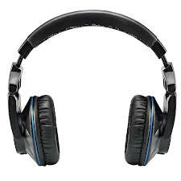
Headphones: Not every student has brought in a pair, but every student MUST have their own. In order for each student to be able to successfully complete the Discovery Education state-mandated Reading and Math tests, having a working pair of headphones is crucial. We start testing next week and will conclude testing by Friday, September 19th.
Classroom Website: I have gone ahead and updated our class website. This week, I will be having students pick an invented name of their own choosing. When we begin our class blog, I use the student’s pseudonyms instead of their real names for anonymity. I will be sending home a list next week so that you can recognize your child’s pen name. Also, I am sending home permission slip forms today asking for your allowance to post your child’s pictures on our webpage. I never attach their real names to their photos. This is to ensure their safety.

Student Allergies: peanuts, tree nuts, corn, and soy. I am sending this information home so when we have Birthdays, everyone can be safely included when foods are brought in. One easy way to avoid reading nutrition labels to check for these is to bring in some healthy fruit for us to celebrate another living year with.

Second Grade Sight Words: Attached to this letter you will find a list of Dolch second grade sight words. Please study these at home. I recommend using note cards (of which I have plenty to give out) to practice them with. I would suggest trying to study five words a week. The idea is that students will be able to quickly recognize these words upon seeing them while reading (hence, the reason why they are called “sight” words).

Sincerely,

Bryan Van Norden
2nd Grade Teacher,
bvannorden@nvanm.org
505-998-0501 Ext. 115

